Name.
Tutor.
Course.
Date.
Drawing as Critical Thinking
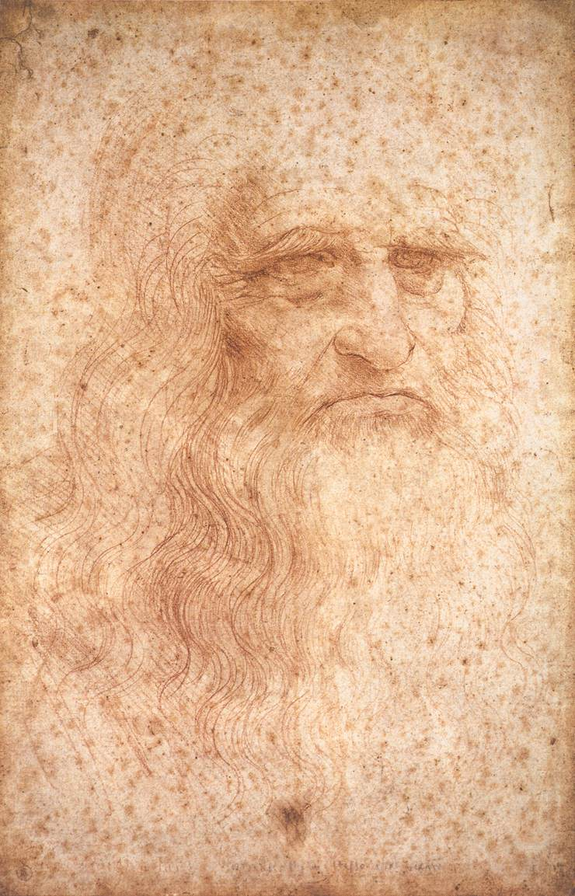
The drawing above "The portrait of a man in red chalk" which is also referred as a self-portrait is one of the earliest creative works of Leonard ad Vinci (1452-1519).Leonard da Vinci was one of the leading artists and intellectuals of the Italian Renaissance era. Leonard was a painter, sculptor, inventor and also a draftsman. The Last Supper and Mona Lisa are other works by Leonard da Vinci which have endured even today, and their relevance in art is highly underscored. "The portrait of a man in red chalk" otherwise referred as a self-portrait was creatively designed to represent the real qualities of Leonard da Vinci, its central themes are individualism and realism, and its effective representation of himself depicts critical thinking.
In the drawing, Leonard da Vinci was studying the concepts of realism and individualism. In other words, Leonard indented to create a drawing that presented his true self, especially in the outward image. As critics argue, the painting was critically and creatively created and it has been preserved in museums and also in internet pages for people to see it and decipher the physical attributes of the famous painter and sculptor (Kemp 65). Leonard da Vinci drew the portrait in red chalk and on paper that measures 33.3cm x 21.6cm.The head represents the head of an elderly man, is presented in a three-quarter view and the face is turned towards the viewer. The subject in the drawing is very distinct and is characterized by long hair and a long beard which rests on the shoulder and the chest (Kemp 17). Deep lines mark the face, and the nose can be described as aquiline, and the subject's face does not face the viewer directly but views ahead.
The portrait of a man in red chalk relied on two main principles of drawing, and these were the three-quarter principle and the principle of preliminary sketches. The three-quarter principle is used as an aspect of preference; though it was not very common during the Renaissance era, it is presented clearly in "the portrait of a man in red chalk." The principle presents objects in three-quarter view as opposed to that of full-face image (Karwowski et al.34). The principle of preliminary sketches was used by majority of Renaissance painters, and hence, it cannot be regarded as a unique aspect of Leonard da Vinci alone. It is also evident that other Renaissance painters such as Raphael Sanzio and Michelangelo also used preliminary sketches before presenting the final drawing. The use of preliminary sketches was relied upon to evaluate whether the final drawing would effectively present the desired theme to the audience without confusion.
Leonard da Vinci can, however, be regarded as the principal Renaissance painter who relied on the preliminary sketches in his artistic process. Leonard had a couple of sketchbooks where he recorded diverse observations concerning nature and also samples of his indented final paintings and drawings (Karwowski et al.34). The sketchbooks were used as medium for improving his drawings and paintings and were filled with pictures as well as notes concerning his interest. Other pages included ideas of concern to inventions, and it was this principle of preliminary sketches which led to the drawing of the "portrait of a man in red chalk." The final portrait was presented in elegant and unique lines. The lines are shadowed by hatching with the left hand, and this was also regarded as one of Leonard's unique painting habit. The paper used for drawing holds some brown marks which are caused by the accumulation of iron salts and moisture (Karwowski et al.34). His sketchbooks were not only motivating him but also gave ideas to new painters, and the publication of the same was central in reaching a wider audience. Majority of his notebooks or sketchbooks presented a hypothesis of what he indented to create.
It is evident that critical thinking formed a foundation for the development to "the portrait of a man in a red chalk" drawing. As earlier indicated, Leonard indented to create a true image of him, and this could not be achieved without critical thinking. The drawing of a man with long beard and long hair was new in the Renaissance era. From the philosophical perspective, long hair and beard represent wisdom, and hence, Leonard wanted to change the thinking of people during this era when enlightenment was yet to be achieved (Da Vinci 55). Renaissance was, therefore, to be taken as a pathway towards enlightenment and an era of wisdom. Since the portrait represented his image, it can also be argued that Leonard wanted to depict himself as wise person and the same qualities were arguably very essential for all people during this era. Even after his death, people can use his drawing to see the true physical image of Leonard da Vinci (Richter 44) Da Vinci's face cannot be regarded as perfect, by this does not take away the fact that he drew it for everyone to see and hence, realism becomes inevitable. His drawing also represents individualism and humanism. Individualism is evident by drawing his features while humanism is depicted through the creation of a drawing that is close to a human person. Generally, the evaluation of the futures of the drawing and the themes presented clearly indicates an aspect of critical thinking by Leonard da Vinci.
In summing up, it is evident that Leonard's use of creative thinking formed the basis of drawing a portrait that represented the themes of individualism, realism, and humanism. Due to Leonard's critical thinking, he is regarded as a genius artist of the Renaissance era. Critical thinking was arguably the basis of his plans, studies, as well as goals and this, is motivated by the fact that he sought to eliminate ambiguity from his drawings, influence more artists and the audience and also to connect his drawings effectively to the themes. Without critical thinking, it would be unlikely for Leonard da Vinci to create drawings which when evaluated, represented the same or indented themes or subject matter.

Works Cited.
Da Vinci, Leonardo. The notebooks of Leonardo da Vinci. Vol. 1. Courier Corporation, 2015.
Karwowski, Maciej, and Arkadiusz Brzeski. "Selfies and the (creative) self: a diary study." Frontiers in psychology 8 (2017).
Kemp, Martin. Leonardo da Vinci: the marvellous works of nature and man. Oxford University Press, 2007.
Richter, Jean Paul, ed. Leonardo da Vinci. Vol. 1. S. Low, Marston, Searle & Rivington, 2015.

